**How to create a navbar in Bootstrap ?**

Bootstrap Navbar is a navigation header that is located at the top of the webpage which can be extended or collapsed, depending on the screen size. Bootstrap Navbar is used to create responsive navigation for our website.

We can create standard navigation bar with <nav class=”navbar navbar-default”>. We can also create different navbar variations such as navbars with drop-down menus and search boxes and a fixed navbar with minimal effort. Below is the procedure to implement a simple static navbar with navigation links.

**Step by Step Guide to implement Navbar in Bootstrap**

Step 1: Include Bootstrap and jQuery CDN into the <head> tag before all other stylesheets to load our CSS.

Step 2: Add <nav> tag with .navbar and .navbar-default class in <body> tag.

Step 3: Add <div> tag with class container-fluid and also add another <div> with class .navbar-header to give name to header and add navigation list after closing <div> tag.

Note: The class .navbar-header is optional.

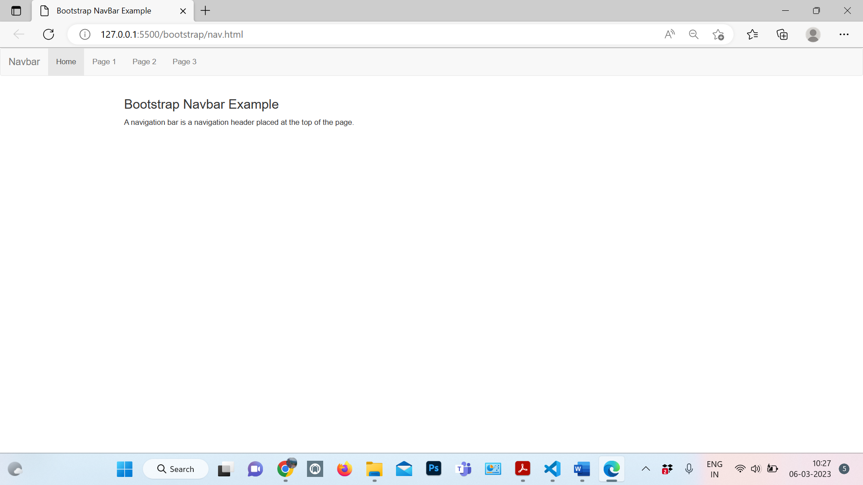

Code:-

<!DOCTYPE html>

<html lang="en">

<head>

    <title>Bootstrap NavBar Example</title>

    <meta charset="utf-8" />

    <!-- Include bootstrap, CSS and jQuery CDN -->

    <meta name="viewport" content=

        "width=device-width, initial-scale=1" />

    <link rel="stylesheet" href=

"https://maxcdn.bootstrapcdn.com/bootstrap/3.4.1/css/bootstrap.min.css" />

    <script src=

"https://ajax.googleapis.com/ajax/libs/jquery/3.5.1/jquery.min.js">

    </script>

    <script src=

"https://maxcdn.bootstrapcdn.com/bootstrap/3.4.1/js/bootstrap.min.js">

    </script>

</head>

<body>

    <!-- Add <nav> tag with .navbar and

         .navbar-default class -->

    <nav class="navbar navbar-default">

        <!-- Add navbar content -->

        <div class="container-fluid">

            <!-- Include .navbar-header class

                 in <div>  (optional)-->

            <div class="navbar-header">

                <a class="navbar-brand" href="#">

                    Navbar

                </a>

            </div>

            <!-- Include navbar list -->

            <ul class="nav navbar-nav">

                <li class="active"><a href="#">

                    Home

                </a></li>

                <li><a href="#">Page 1</a></li>

                <li><a href="#">Page 2</a></li>

                <li><a href="#">Page 3</a></li>

            </ul>

        </div>

    </nav>

    <!-- Sample page content -->

    <div class="container">

        <h3>Bootstrap Navbar Example</h3>

        <p>

            A navigation bar is a navigation

            header placed at the top of the page.

        </p>

    </div>

</body>

</html>

Example 2- Navbar with Dropdown

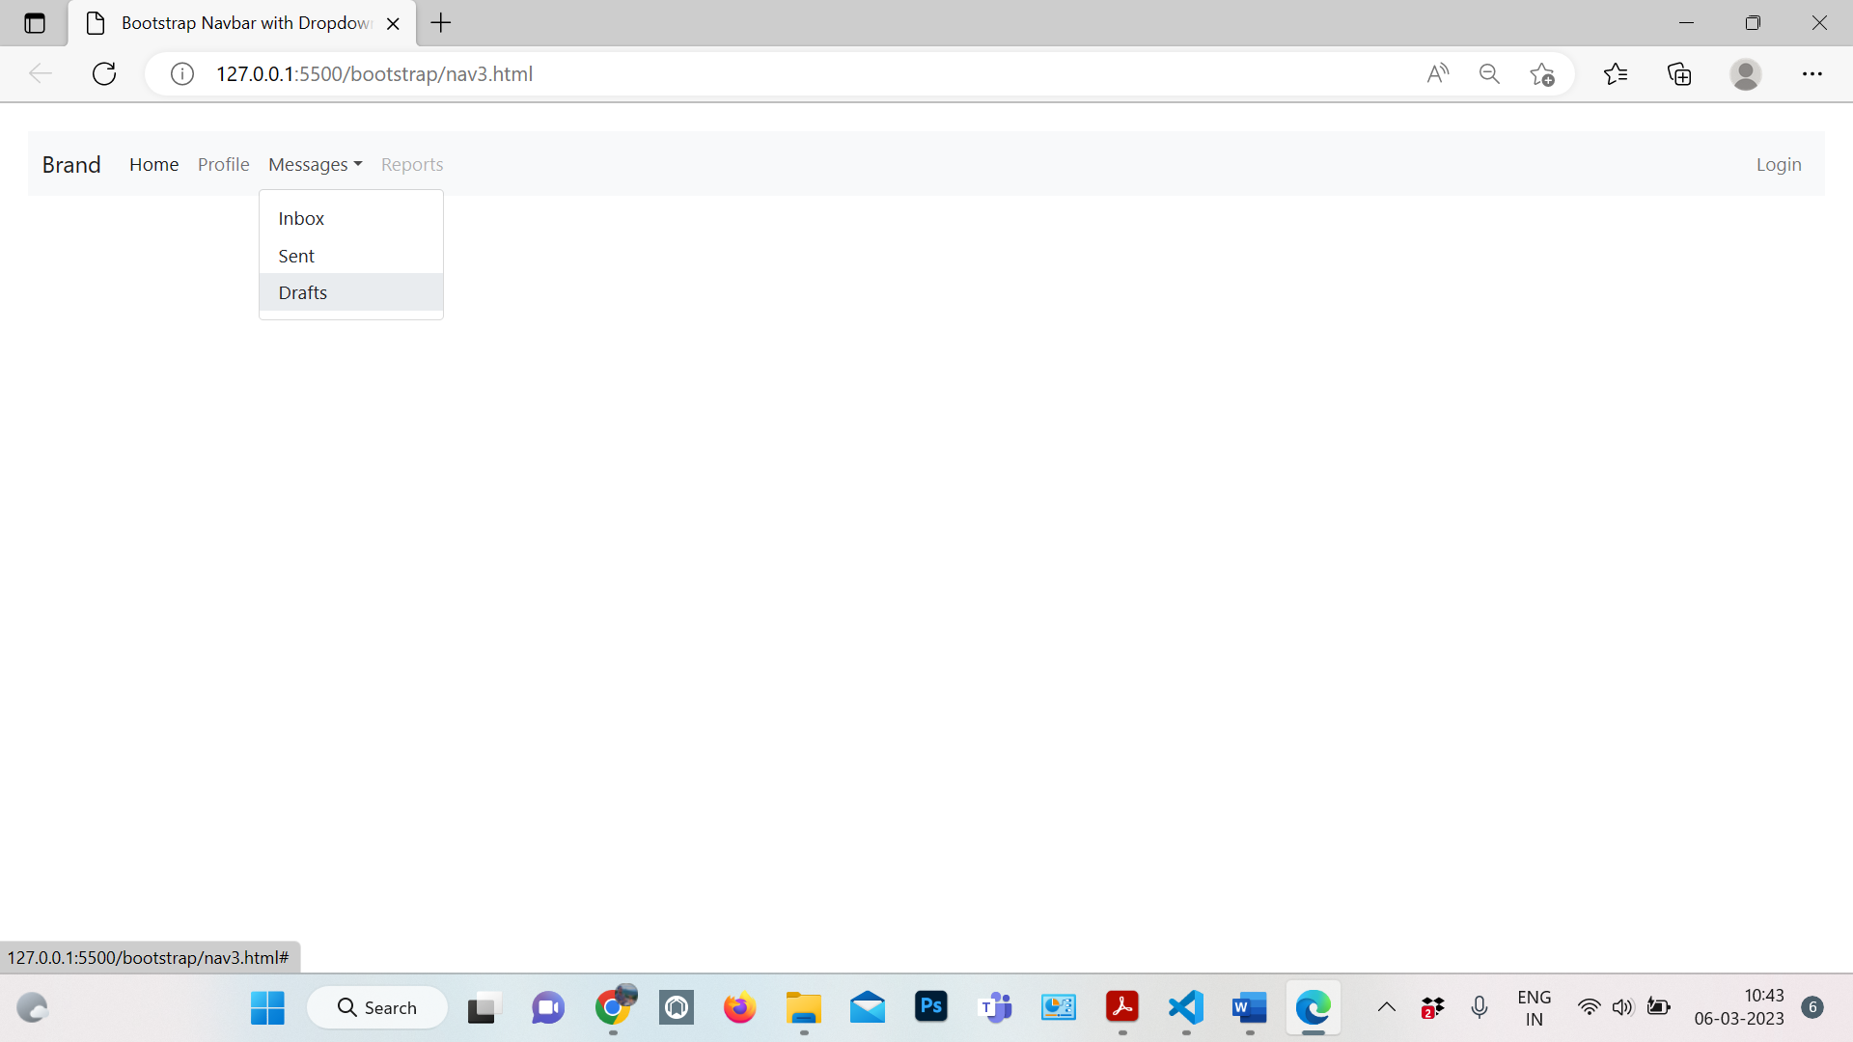

Code:

<!DOCTYPE html>

<html lang="en">

<head>

<meta charset="utf-8">

<meta name="viewport" content="width=device-width, initial-scale=1">

<title>Bootstrap Navbar with Dropdown</title>

<link href="https://cdn.jsdelivr.net/npm/bootstrap@5.0.2/dist/css/bootstrap.min.css" rel="stylesheet">

<script src="https://cdn.jsdelivr.net/npm/bootstrap@5.0.2/dist/js/bootstrap.bundle.min.js"></script>

</head>

<body>

<div class="m-4">

    <nav class="navbar navbar-expand-lg navbar-light bg-light">

        <div class="container-fluid">

            <a href="#" class="navbar-brand">Brand</a>

            <button type="button" class="navbar-toggler" data-bs-toggle="collapse" data-bs-target="#navbarCollapse">

                <span class="navbar-toggler-icon"></span>

            </button>

            <div class="collapse navbar-collapse" id="navbarCollapse">

                <div class="navbar-nav">

                    <a href="#" class="nav-item nav-link active">Home</a>

                    <a href="#" class="nav-item nav-link">Profile</a>

                    <div class="nav-item dropdown">

                        <a href="#" class="nav-link dropdown-toggle" data-bs-toggle="dropdown">Messages</a>

                        <div class="dropdown-menu">

                            <a href="#" class="dropdown-item">Inbox</a>

                            <a href="#" class="dropdown-item">Sent</a>

                            <a href="#" class="dropdown-item">Drafts</a>

                        </div>

                    </div>

                    <a href="#" class="nav-item nav-link disabled" tabindex="-1">Reports</a>

                </div>

                <div class="navbar-nav ms-auto">

                    <a href="#" class="nav-item nav-link">Login</a>

                </div>

            </div>

        </div>

    </nav>

</div>

</body>

</html>

**Reference for some more types of Navbar :**

https://www.tutorialrepublic.com/twitter-bootstrap-tutorial/bootstrap-navbar.php